Application Mock-up

This document defines the process of registering an institution from a handheld device.

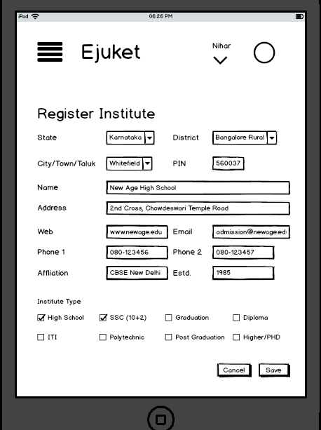

Once the institution is recorded, further course details can be added as per the selection in the above screen:

The next screen will ask for the details on the course for 10+2, user need to click on Add Stream, to add one stream under the course and it can also add multiple streams like science, Arts and commerce.

Once a stream is added, most of the items will be auto populated (accordion) and the user has to select the subjects available under that stream. But the subjects will be auto populated based on the course and stream. On addition of the another stream, the previous screen details can be hidden/collapsed.

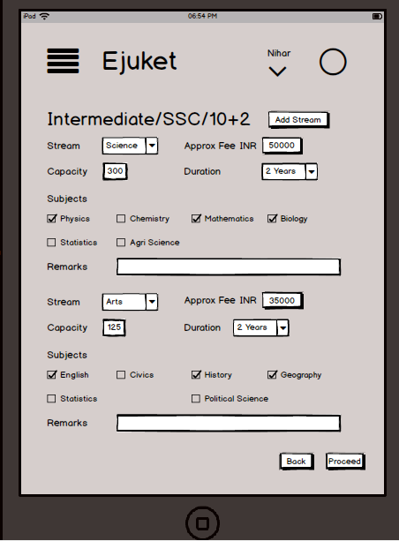

Similar screens to continue based on the course selected on the 1st screen. Once all the courses are completed, the following screen will capture other additional information about the institute.

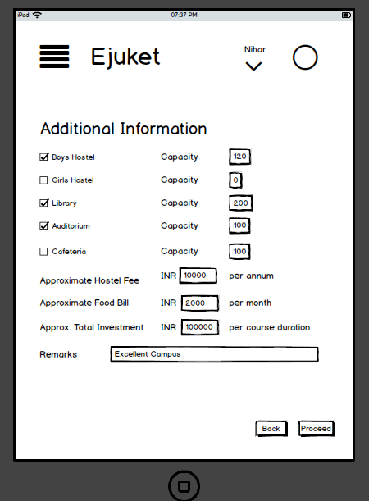

The above all screens are for data cap

ture. The following is for providing service to customers which will help in finding the appropriate institute for a candidate.

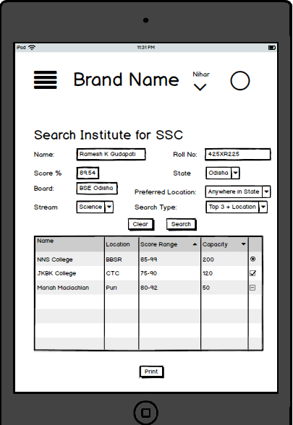

Intermediate in Science Subjects:

Mandatory:

Physics, Chemistry, Mathematics, Biology (Botany & Zoology), Economics, Computer Science, Statistics, Biotechnology, Engineering Drawing, English, Hindi, Regional Language, Engineering Graphics, Home Science, Informatics Practices, Multimedia and Web Technology

Optional:

Intermediate in Arts Subjects:

History, Political Science, Geography, Psychology, Sociology, Physical Education, Fashion Studies, Education, Logic, Statistics, English, Sanskrit, Hindi, Regional Languages

Intermediate in Commerce Subjects:

Streams in Diploma in Engineering

ITI Subjects